PROJECT REPORT
ON
DAILY PLANNER SYSTEM
Submitted in partial fulfilment of Bachelor of Computer
Applications
To
Uttaranchal University



Uttaranchal School of Computing Sciences
SESSION (2025-26)

Under the supervision of: Submitted by:
Ms. Manisha Khanduja Khushbu Rawat
(Assistant professor ) Enroll. UU250900181
BCA. II sem.
Section F

ACKNOWLEDGEMENT

The successful completion of any task is never possible without the support and cooperation of many individuals. This project is the result of continuous encouragement, valuable guidance, and consistent assistance from respected mentors and faculty members.
First and foremost, I extend my heartfelt thanks to Prof. (Dr.) Sonal Sharma, Director–USCS, for providing a positive and motivating academic environment that encouraged learning and growth throughout the course of this study.
I am deeply grateful to Prof. (Dr.) Sameer Dev Sharma, Head of Department–USCS, for his constant support, constructive suggestions, and guidance that helped me successfully develop and complete this project Finally.
I express my sincere appreciation to Ms. Manisha Khanduja, Project Mentor, Assistant Professor–USCS, for her valuable guidance, patience, encouragement, and continuous support at every stage of the project.

Khushbu Rawat
B.C.A 2 semester
Section-F

DECLARATION

I hereby declare that the project report entitled “Daily Planner System” submitted by Khushboo Rawat to Uttaranchal School of Computing science. The project report was done under the guidance of Ms. Manisha Khanduja, Assistance professor-USCS. I confirm that this project has not been submitted to any other institution or university for the award of any degree, diploma, or certificate. All sources of information used in this project have been properly acknowledged wherever necessary.

Khushbu Rawat
Enroll No UU2509000181
B.C.A 2nd semester
Section:- ‘F’

CERTIFICATE

This is to certify that Khushbu Rawat of BCA 2 semester, of Uttaranchal School of Computing Sciences, Dehradun has been successfully completed the project report, for the “Daily Planner System” for the session (2025-2026).

Under the guidance of:
Ms. Manisha Khanduja
Assistant professor-USCS
Uttaranchal University

TABLE OF CONTENTS
S.NO. | CONTENT | PAGE NO.
 | Acknowledgement | I
 | Declaration | II
 | Certificate | III
1. | Introduction  1.1Objective of the project  1.2Scope of the project | 1-2
2. | System Analysis/Requirement  2.1 System analysis  2.2 System requirement  2.3 Feasibility study  2.3.1 Operational feasibility  2.3.2 Economical feasibility  2.3.3 Technical feasibility | 3-8
3. | Planning  3.1 Project planning overview  3.2 Gantt chart  3.3 Flow chart  3.4 Class diagram  3.5 Data flow diagram | 9-13
4. | System Design and Module Structure  4.1 Number of Modules and description  4.2 Data structures used in the project  4.3Proposed Security Mechanisms | 14-19
5. | Testing  5.1 Integrating testing  5.2 Unit testing  5.3 Sample test cases | 20-21
6. | Security Mechanism  6.1 System security measures | 22-24
7. | Future Scope and Further Enhancement | 25
8. | Code
9. | Bibliography | 26

INTRODUCTION
We need a daily planner because without proper planning, our day becomes unorganized and unproductive. Many people forget important tasks, waste time, or feel stressed due to poor time management. A daily planner helps prioritize work, manage deadlines, and reduce confusion. It brings clarity, focus, and better control over daily activities. A daily planner helps in setting clear priorities, allocating time effectively, and tracking progress throughout the day. It improves focus, reduces procrastination, and ensures that both personal and professional tasks are completed on time.
The primary purpose of this project is to study the importance of using a daily planner in managing time effectively and improving overall productivity. It aims to examine the common problems caused by poor planning, such as missed deadlines, stress, and lack of focus. This project also seeks to understand how a daily planner helps in organizing tasks, setting clear priorities, maintaining discipline, and achieving goals in a systematic and efficient manner. Most people manage their daily tasks mentally or through unorganized methods like random notes, reminders, or memory-based planning. There is no proper structure to prioritize tasks, which often leads to confusion and missed deadlines. Many individuals rely on last-minute planning, which increases stress and reduces productivity.

Due to the lack of a systematic approach, time is not utilized efficiently, and important tasks may be overlooked. There is no clear categorization of urgent and non-urgent tasks, which leads to poor time management. People often focus on easy tasks first and delay important ones, resulting in last-minute pressure and incomplete work. It is to develop and analyse a daily planner system that helps individuals manage their time and tasks more effectively. It focuses on improving productivity by organizing daily activities, setting priorities, and tracking progress in a structured manner. This project can be useful for students, employees, and professionals who face challenges in time management. It covers features such as task scheduling, goal setting, reminder systems, and performance tracking.

The core strength of this project lies in its simplicity and practical usefulness. The daily planner system is designed to be easy to use, making it accessible for students, employees, and professionals without requiring technical knowledge. Its structured approach to organizing tasks helps users clearly identify priorities and manage time effectively. Another major strength is its ability to improve productivity and reduce stress by providing a clear daily schedule. The system encourages discipline, consistency, and goal-oriented behaviour. This project include students, working professionals, and business individuals who need better time management in their daily lives. Students can use the planner to manage assignments, exams, and study schedules effectively. Employees and professionals can utilize it to organize meetings, deadlines, and daily work tasks in a structured manner. Additionally, homemakers and entrepreneurs can also benefit from planning their daily responsibilities efficiently. Overall, this project is suitable for anyone who wants to improve productivity, reduce stress, and manage time in a systematic way.

Overall, the Daily Planner System provides a simple, organized, and effective solution to the common problem of poor time management. It replaces unstructured and memory-based planning with a systematic approach that helps users prioritize tasks, manage schedules, and track daily progress efficiently. By integrating user-friendly design with practical planning features, the project improves productivity, reduces stress.

1.1 Objective of the Project
1. Task Organization: The Daily Planner System allows users to list and arrange all their tasks in a structured format. Instead of remembering everything mentally, users can store tasks in one place. It reduces confusion and ensures that no important work is overlooked. Tasks can also be categorized (e.g., personal, academic, work) for better clarity.
2. Time Management: By planning when to start and finish activities, users can avoid wasting time and make better use of their day. It also helps in balancing different responsibilities, such as study, work, and leisure.
3.Task Prioritization:
Not all tasks have the same importance. The planner allows users to mark tasks as high, medium, or low priority. This ensures that urgent and important tasks are completed first, reducing the risk of missing deadlines or delaying critical work.
4.Progress Tracking: This helps users monitor their daily progress and stay motivated. Seeing completed tasks gives a sense of achievement and encourages consistency.

1.2 Scope of the project
• User-Friendly Interface: The system will be designed with a simple and easy-to-use interface so that users can access and manage tasks without difficulty.
• Task Creation and Management: Users can add, edit, delete, and organize daily tasks based on their needs.
• Scheduling Features: The system will allow users to assign dates and time slots to tasks for proper planning.
• Reminder System: It will provide notifications or alerts to remind users about important tasks and deadlines.
• Priority Setting: Users can set priorities (high, medium, low) to manage tasks effectively.
• Progress Monitoring: The system will help users track completed and pending tasks.
• Data Storage: The planner will store task information securely for future reference.
• Accessibility: The system can be accessed easily, making it convenient for daily use.

2. SYSTEM ANALYSIS/REQUIREMENT

System Analysis serves as the foundation of the Daily Planner System, focusing on understanding the limitations of the current unstructured task management methods. At present, many individuals rely on memory, scattered notes, or basic reminder applications that lack proper organization and prioritization. This often results in missed deadlines, overlapping schedules, reduced productivity, and increased stress. The absence of a centralized system makes it difficult to track daily progress, evaluate completed tasks, or maintain consistency in planning.
The system is designed to allow users to create, update, prioritize, and monitor tasks efficiently. By storing task details in a well-organized database, the planner ensures that information is easily accessible and systematically arranged. Features such as reminders, deadline tracking, and progress monitoring help users stay focused and maintain better control over their schedules. This structured approach minimizes confusion and enhances overall productivity. The system must ensure that user data, such as personal schedules and task details, is stored securely and protected from unauthorized access Moreover, the planner should be flexible enough to allow customization based on individual preferences, such as setting task categories, priority levels, and notification settings.
The importance of scalability and future enhancement as essential requirements of the Daily Planner System. The system should be designed in a way that allows the addition of new features such as calendar integration, performance reports, cloud backup, and multi-device access without affecting its performance.
From a feasibility perspective, the system has been analysed in terms of technical, operational, and economic aspects. Technically, it can be developed using standard web technologies and database systems, ensuring reliability and scalability. Operationally, the system is simple and user-friendly, requiring minimal training for users. Economically, the project is cost-effective as it reduces time wastage and improves efficiency.

2.1 System Analysis

The Daily Planner System involves studying the current methods of managing daily tasks and identifying the problems associated with them. Most individuals rely on memory, paper notes, or basic mobile reminders, which often lead to missed deadlines, poor prioritization, and inefficient time management. The proposed system aims to overcome these issues by introducing a digital platform that organizes tasks in a systematic manner. It allows users to add, update, delete, and prioritize tasks while also setting deadlines and reminders. By maintaining all information in a structured database, the system ensures easy retrieval, better tracking, and improved accuracy.
In the Daily Planner System project, system analysis helps identify the problems users face while managing their daily tasks and determines how a computerized solution can solve those problems. Many people rely on notebooks, sticky notes, or memory to remember their daily activities, which can lead to forgotten tasks, poor time management, and disorganized schedules. During this stage, the functions that the system must perform are identified, such as adding new tasks, viewing the list of tasks, editing existing tasks, and deleting completed or unnecessary tasks.
System analysis also considers the requirements needed for the program to run successfully, including basic hardware like a computer and software tools such as a C++ compiler and operating systems. By carefully analyzing the system, developers can design a program that is simple, efficient, and easy for users to understand. The analysis stage also helps reduce errors during development because the requirements and functions of the system are clearly defined before coding begins. In the Daily Planner System, system analysis ensures that the program will help users organize their daily activities effectively, improve productivity, and make task management easier.

2.2 System Requirements

HARDWARE AND SOFTWARE
●OS - Window 11
●PROCESSOR - Intel core i5
●Installed Memory - 16.0 GB
●HARDWARE AND SOFTWARE MINIMUM REQIREMENT
●OS - Window 11
●GRAPHIC CARD -Intel iRISxe
●OPERATING SYSTEM - Intel CORE i5
TECHNOLOGY USED
C++ Programming
2.3 Feasibility Study
A feasibility study is conducted to determine whether the Daily Planner System is practical and achievable before development begins. It evaluates different aspects of the project to ensure that it can be implemented successfully without major risks. From a technical point of view, the system can be created using simple and easily available technologies, so there is no major difficulty in development. From an economic point of view, the cost of creating and maintaining the system is low compared to the benefits it provides, such as better productivity and time management.

2.3.1 Operational Feasibility
The system is designed with a simple and user-friendly interface so that students, employees, and other users can operate it without requiring technical expertise or special training. Clear navigation, easy task management options, and simple reminder settings ensure smooth usability. The system also supports daily routine activities by allowing users to add, update, and track tasks quickly. Since it solves common problems like missed deadlines and poor organization, users are likely to accept and regularly use the system. Therefore, the Daily Planner System is operationally feasible as it meets user needs and can be smoothly integrated into daily life.

2.3.2 Economical Feasibility
Economic feasibility evaluates whether the Daily Planner System is financially viable and cost-effective. It analyses the total cost of development, implementation, and maintenance in comparison to the benefits it provides. The system can be developed using commonly available software tools and technologies, which reduces development expenses. Since it does not require expensive hardware or advanced infrastructure, the initial investment is minimal. By saving time and increasing efficiency, the system indirectly contributes to better performance and output. Therefore, the Daily Planner System is economically feasible as it provides significant value at a reasonable cost.

2.3.3 Technical Feasibility

Technical feasibility means checking whether the project can be developed and run using the available technology, tools, and skills. In the Daily Planner System project, technical feasibility is very high because the system is simple and does not require complex technology. The program can be developed using the C++, which is a widely used and beginner-friendly programming language for creating console-based applications. Most students and developers already learn basic concepts of C++, such as variables, loops, functions, and file handling, which are enough to build this system. The system also does not require advanced hardware. A basic computer or laptop with a keyboard and monitor is enough to run the program.

3. PLANNING
Planning is the first and most essential phase in the Software development. In this stage, the goals and purpose of the project are clearly defined so that the development process moves in the right direction. It involves understanding the problem, identifying user needs, and deciding how the system will solve those issues effectively. Proper planning ensures that the project has a clear vision and structured approach.
During the planning phase, resources such as time, manpower, and technology are carefully analysed and allocated. A detailed project schedule is prepared, including different phases like system analysis, design, development, testing, and implementation. Responsibilities are assigned to team members to ensure smooth coordination and efficient workflow. This stage also includes estimating the cost and setting deadlines for completing each task.
Risk management is another important part of planning. Possible challenges, such as technical issues or delays, are identified in advance, and strategies are prepared to handle them. This reduces uncertainty and improves project stability. Clear communication and documentation are also maintained to avoid misunderstandings during development. Each stage of development—analysis, design, coding, testing, and deployment—is carefully organized to avoid confusion and overlapping work. Proper documentation is also prepared to record decisions, system specifications, and workflow processes for future reference.
Planning also focuses on quality assurance and performance expectations. Standards are defined to ensure that the system meets required quality levels. Backup plans and alternative solutions are prepared in case of unexpected issues Planning is a continuous and strategic process that ensures the successful development of the Daily Planner System Backup plans and alternative solutions are prepared in case of unexpected issues. Regular review meetings and progress tracking are included to monitor development and ensure the project stays on schedule.
Overall, effective planning acts as a roadmap for the Daily Planner System, guiding the project from beginning to completion in a systematic, organized, and efficient manner.

3.1 Planning Overview
The planning overview gives a complete picture of how the project will be organized and executed. It clearly defines the purpose of the system, the problems it aims to solve, and the expected outcomes. This stage ensures that all team members understand the project goals and work in a coordinated manner toward a common objective. A well-prepared overview prevents confusion and sets a clear direction for development.
In this phase, the scope of the project is determined to avoid unnecessary features and focus only on essential requirements. A detailed timeline is prepared that divides the project into phases such as system analysis, design, development, testing, and implementation. Resources such as tools, technology, budget, and manpower are carefully planned to ensure smooth execution. The planning overview also includes setting milestones to track progress at each stage.
Additionally, risk assessment and quality standards are included in the planning overview. Possible challenges like technical issues, delays, or resource limitations are identified in advance, and solutions are prepared to handle them. Clear documentation and communication strategies are established to maintain transparency throughout the project.
Important aspect of the planning overview is resource optimization. It identifies the technical tools, software platforms, financial budget, and human resources required for successful execution. Proper allocation of these resources helps prevent wastage of time and cost overruns. The overview also sets performance expectations and quality benchmarks that the system must meet.
Monitoring and control mechanisms are also part of the planning overview. Regular progress evaluation, milestone tracking, and feedback analysis ensure that the project remains aligned with its goals. Any deviation from the plan can be corrected at an early stage to avoid major complications. In addition, the planning overview considers future scalability and long-term sustainability of the system. It ensures that the Daily Planner System can be upgraded or expanded with additional features as user needs evolve.
Overall, the planning overview acts as a structured roadmap that ensures the Daily Planner System is developed efficiently, within budget, and according to user expectations while maintaining quality and reliability.
3.2 Gantt Chart

A Gantt Chart is a visual tool used in project management to plan, schedule, and track tasks over a specific period of time. It displays tasks or activities on one side and time (days, weeks, or months) on the other, using horizontal bars to show the start and end dates of each task.

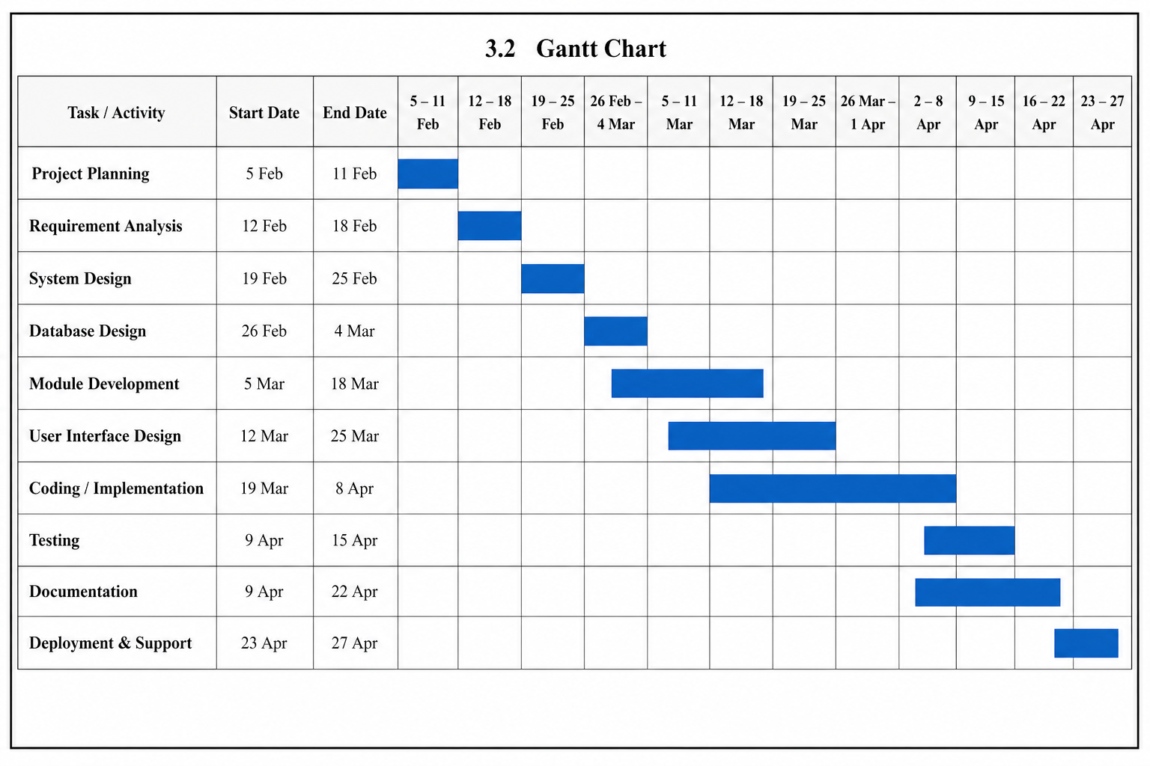

3.3 FLOWCHART
START

Initialize Planner

Loading Screen

Main Menu

Login
Yes
Register

No
User Menu
Wrong Login

3.4 CLASS DIAGRAM
End
Logout

Update Task
Delete Task
Add Task
View Task
DAILY PLANNER
-PLANNER DATE
-TASK LIST
+VIEW TASK ()
+ADD TASK ()
+REMOVE TASK ()
REMINDER

-REMINDER ID
-TIME

+SET REMINDER ()
+SEND REMINDER ()

TASK

-TASK ID
-DATE
-STATUS

+ADD TASK ()
+UPDATE TASK ()
+DELETE TASK ()

USERS

-USER ID
-NAME
-EMAIL
+LOGIN ()
+LOGOUT ()

1
Creates

*

1 has *

*contains
1

3.5 Data Flow Diagram
A data flow diagram (DFD) is a graphical representation of how data moves through a system, showing its flow input to output through various processes and storage location.

DFD Level 0 – Daily Planner System
DFD Level -0 is also called the context diagram. It represents the overall working of the Daily Planner System. In this diagram, the user interacts with the system to add, view, update, or delete daily task.

0.0
Daily Planner System

Task Details Task Info
Admin
User

Task List Sy system Management

DFD Level 1 – Daily Planner System
DFD Level – 1 show the detailed working of the Daily Planner System. In this level, the main process is divided into smaller processes such as adding task, viewing task, updating task, and deleting task. The user interacts with the system to manage daily activities, while the admin can monitor and manage task information

1.1Register/Login

Add Task
Task Info Task Info
1.2 Manage Task
User
1.3 Check Task List
1.4 Delete Task
Admin
Task Info Task Info

Admin
Management
Task
Delete Task Schedule
Admin
Data

4. SYSTEM DESIGN AND MODULE STRUCTURE
System Design explains how the Daily Planner system will work, how data will flow, and how users will interact with the system. The module structure of the Daily Planner is divided into several functional modules to improve efficiency and maintainability. The User Management Module handles registration, login authentication, profile updates, and password management. The Task Management Module acts as the core component of the system, allowing users to create tasks, set deadlines, assign priorities, edit task details, and track completion status. The Reminder and Notification Module sends alerts for upcoming or missed tasks to help users stay organized. The Daily Planner system is designed to help users manage their daily tasks, set reminders, and track productivity. The system will store task details in a database and provide a user-friendly interface for adding, editing, deleting, and viewing tasks.
S
4.1 Numbers of modules and Description

The Daily Planner system is divided into 5 main modules. Each module performs a specific function to ensure smooth working of the system.
1.User Management Module
This module manages all user-related activities. It allows users to register, log in, log out, and update their profile details. It also handles password security and authentication to ensure that only authorized users can access their tasks and personal data.
2. Task Management Module
This is the core module of the system. It enables users to add new tasks, edit existing tasks, delete tasks, set priorities, and mark tasks as completed. It also stores details like task title, description, deadline, and status.
3. Reminder and Notification Module
This module helps users stay on track by sending reminders for upcoming tasks. It notifies users about pending or missed tasks and ensures that important activities are not forgotten.
4. Calendar and Scheduling Module
This module organizes tasks according to date and time. It provides daily and weekly views of tasks and helps users schedule activities in specific time slots for better time management.
5. Reports and Productivity Module
This module generates reports showing completed and pending tasks. It helps users analyse their daily or weekly productivity and track their performance over time.

4.2 Data Structure used in Project
1.Array
An array is used to store multiple tasks in a list format. Each task can be stored at a specific index position. Arrays help in displaying tasks sequentially (for example, daily task list). It is simple and useful for fixed-size data storage.
2. List (Array List / Linked List)
A dynamic list is commonly used to store tasks because the number of tasks can increase or decrease. It allows easy addition, deletion, and modification of tasks without fixed size limitations. This is one of the most important data structures in the Daily Planner system.
3. Stack
A stack is used to implement features like undo and redo operations. For example, if a user deletes a task accidentally, the system can restore it using stack operations (Last In First Out – LIFO).
4. Queue
A queue can be used in the Reminder Module to manage notifications. Tasks are processed in the order they are scheduled (First In First Out – FIFO), which helps in sending reminders correctly.

4.3 Proposed Security Mechanism
The security architecture of the Daily Planner Management System is designed to ensure the confidentiality, integrity, and availability of user data. By implementing a multi-layered security approach, the system protects against both external cyber threats and internal misuse. The following security mechanisms are proposed to maintain a secure and reliable platform.
Role-Based Access Control:-
To maintain strict operational control, the system implements Role-Based Access Control to differentiate between administrators and general users. Administrators have full authority to manage user accounts, settings, and system configurations, while regular users can only create, edit, or delete their own tasks and schedules. This prevents unauthorized access or modification of sensitive data.
Encrypted Authentication:
Security begins at the login stage, where user credentials are protected using secure hashing algorithms. Passwords are never stored in plain text, reducing the risk of data exposure in case of a breach. Additionally, secure session management techniques are used to prevent session hijacking and unauthorized login attempts.
Input Validation and Data Sanitization:
To protect the system from common vulnerabilities such as SQL injection and cross-site scripting, strict input validation mechanisms are applied. All user inputs are validated and sanitized before being processed by the system. This ensures that malicious scripts or harmful data cannot compromise the database or application logic.
Network and System Security:
The system is protected by firewalls and secure communication protocols. Regular software updates and security patches are applied to prevent vulnerabilities. Antivirus protection and periodic security testing further strengthen the system’s defence mechanisms.

TESTING

Testing is an essential phase in the development of the Daily Planner Management System. It ensures that the system functions correctly, meets user requirements, and operates without errors. The main objective of testing is to identify and fix bugs, verify system performance, and ensure reliability before deployment. The following testing strategies are implemented:
Unit Testing:
Unit testing is performed to verify individual modules of the system such as user registration, login, task creation, reminder settings, and task deletion. Each component is tested separately to ensure it works as expected without errors.
Integration Testing:
Integration testing ensures that different modules of the system work together properly. For example, testing whether the login module correctly connects with the database or whether task updates are accurately reflected in the user dashboard.

SECURITY MECHANISM
Although the system is application-based, basic and advanced security mechanisms are implemented to maintain data confidentiality, integrity, and prevent unauthorized access. The following security measures are included:
Login Authentication:
Access to the system is restricted using a secure username and password. Only registered users can log in to access their personal planner data.
Password Encryption:
User passwords are encrypted using secure hashing techniques. Passwords are not stored in plain text, ensuring protection even if the database is compromised.
Role-Based Access Control:
The system differentiates between Admin and General Users. Admin can manage user accounts and system settings, while users can only access and modify their own tasks.
Input Validation:
All user inputs are validated to prevent invalid data entries and protect against common vulnerabilities like SQL Injection and Cross-Site Scripting (XSS).

6.1 System Security Measures
The Daily Planner System is designed with essential security mechanisms to protect user data and ensure safe system operation. The system maintains confidentiality, integrity, and availability of information through the following measures:
1. Authentication Mechanism:
The system requires users to log in using a valid username and password. Registered users can access the system. This prevents unauthorized access.
2. Password Encryption:
Passwords are stored in encrypted (hashed) format rather than plain text. This ensures that even if the database is compromised, passwords remain protected.
3. Role-Based Access Control :
Access rights are assigned based on user roles. The Admin can manage users and system settings, while general users can only manage their own tasks and personal data.

SCOPE AND FUTURE ENHANCEMENT

The Daily Planner System has wide potential for expansion and improvement. In the future, the system can be developed into a full-featured productivity management application with advanced functionalities. It can be integrated with cloud services to allow access from multiple devices such as mobile phones, tablets, and desktops.
Some possible future enhancements are :-
• Mobile Application Integration:
In the future, the system can be developed as a mobile application so users can access their planner anytime and anywhere. This will make it more convenient compared to using it only on a computer.
• Cloud Synchronization:
The system can store data on cloud servers, allowing users to access their tasks from different devices like phones, tablets, or laptops. It also ensures data backup and prevents data loss.
• Advanced Notifications:
Future versions can include smarter reminders such as push notifications, emails, or alarm alerts. These reminders can be customized based on user preferences.
• User Authentication:
A secure login system can be added to protect user data. Each user will have a unique account with a username and password, ensuring privacy and security.
• AI-Based Suggestions:
The system can use artificial intelligence to analyze user habits and suggest task priorities, schedules, or reminders automatically, making planning more efficient.

#include <iostream>
#include <fstream>
#include <string>
using namespace std;

class Task
{
public:
int id;
string title;
string date;
string time;
string priority;
bool completed;

void addTask()
{
cin.ignore();

cout << "\nEnter Task Title: ";
getline(cin, title);

cout << "Enter Date (DD/MM/YYYY): ";
getline(cin, date);

cout << "Enter Time: ";
getline(cin, time);

cout << "Enter Priority (High/Medium/Low): ";
getline(cin, priority);

completed = false;
}

void displayTask()
{
cout << "\n-----------------------------------";
cout << "\nTask ID : " << id;
cout << "\nTitle : " << title;
cout << "\nDate : " << date;
cout << "\nTime : " << time;
cout << "\nPriority : " << priority;

if (completed)
cout << "\nStatus : Completed";
else
cout << "\nStatus : Pending";

cout << "\n-----------------------------------\n";
}
};

void saveTask(Task t)
{
ofstream file("planner.txt", ios::app);

file << t.id << endl;
file << t.title << endl;
file << t.date << endl;
file << t.time << endl;
file << t.priority << endl;
file << t.completed << endl;

file.close();

cout << "\nTask Saved Successfully!\n";
}

void viewTasks()
{
ifstream file("planner.txt");

if (!file)
{
cout << "\nNo Tasks Found!\n";
return;
}

Task t;

while (file >> t.id)
{
file.ignore();

getline(file, t.title);
getline(file, t.date);
getline(file, t.time);
getline(file, t.priority);

file >> t.completed;

t.displayTask();
}

file.close();
}

void searchTask()
{
ifstream file("planner.txt");

if (!file)
{
cout << "\nNo Tasks Available!\n";
return;
}

int searchId;
bool found = false;

cout << "\nEnter Task ID to Search: ";
cin >> searchId;

Task t;

while (file >> t.id)
{
file.ignore();

getline(file, t.title);
getline(file, t.date);
getline(file, t.time);
getline(file, t.priority);

file >> t.completed;

if (t.id == searchId)
{
cout << "\nTask Found!\n";
t.displayTask();
found = true;
break;
}
}

if (!found)
{
cout << "\nTask Not Found!\n";
}

file.close();
}

void markCompleted()
{
ifstream file("planner.txt");

if (!file)
{
cout << "\nNo Tasks Available!\n";
return;
}

ofstream temp("temp.txt");

int taskId;
bool found = false;

cout << "\nEnter Task ID to Mark Completed: ";
cin >> taskId;

Task t;

while (file >> t.id)
{
file.ignore();

getline(file, t.title);
getline(file, t.date);
getline(file, t.time);
getline(file, t.priority);

file >> t.completed;

if (t.id == taskId)
{
t.completed = true;
found = true;
}

temp << t.id << endl;
temp << t.title << endl;
temp << t.date << endl;
temp << t.time << endl;
temp << t.priority << endl;
temp << t.completed << endl;
}

file.close();
temp.close();

remove("planner.txt");
rename("temp.txt", "planner.txt");

if (found)
cout << "\nTask Marked as Completed!\n";
else
cout << "\nTask ID Not Found!\n";
}

void deleteTask()
{
ifstream file("planner.txt");

if (!file)
{
cout << "\nNo Tasks Available!\n";
return;
}

ofstream temp("temp.txt");

int deleteId;
bool found = false;

cout << "\nEnter Task ID to Delete: ";
cin >> deleteId;

Task t;

while (file >> t.id)
{
file.ignore();

getline(file, t.title);
getline(file, t.date);
getline(file, t.time);
getline(file, t.priority);

file >> t.completed;

if (t.id != deleteId)
{
temp << t.id << endl;
temp << t.title << endl;
temp << t.date << endl;
temp << t.time << endl;
temp << t.priority << endl;
temp << t.completed << endl;
}
else
{
found = true;
}
}

file.close();
temp.close();

remove("planner.txt");
rename("temp.txt", "planner.txt");

if (found)
cout << "\nTask Deleted Successfully!\n";
else
cout << "\nTask ID Not Found!\n";
}

int main()
{
int choice;
Task t;

do
{
cout << "\n========== DAILY PLANNER SYSTEM ==========";
cout << "\n1. Add New Task";
cout << "\n2. View All Tasks";
cout << "\n3. Search Task";
cout << "\n4. Mark Task as Completed";
cout << "\n5. Delete Task";
cout << "\n6. Exit";
cout << "\nEnter Your Choice: ";
cin >> choice;

switch (choice)
{
case 1:
cout << "\nEnter Task ID: ";
cin >> t.id;

t.addTask();
saveTask(t);
break;

case 2:
viewTasks();
break;

case 3:
searchTask();
break;

case 4:
markCompleted();
break;

case 5:
deleteTask();
break;

case 6:
cout << "\nThank You For Using Daily Planner System!\n";
break;

default:
cout << "\nInvalid Choice!\n";
}

} while (choice != 6);

return 0;
}

OUTPUT:
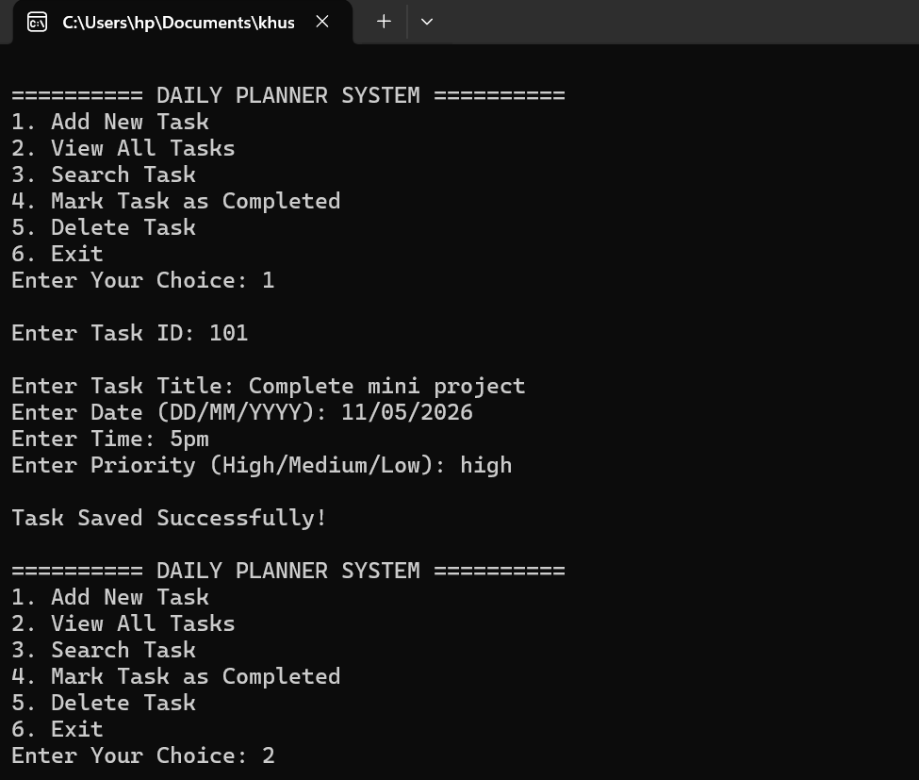
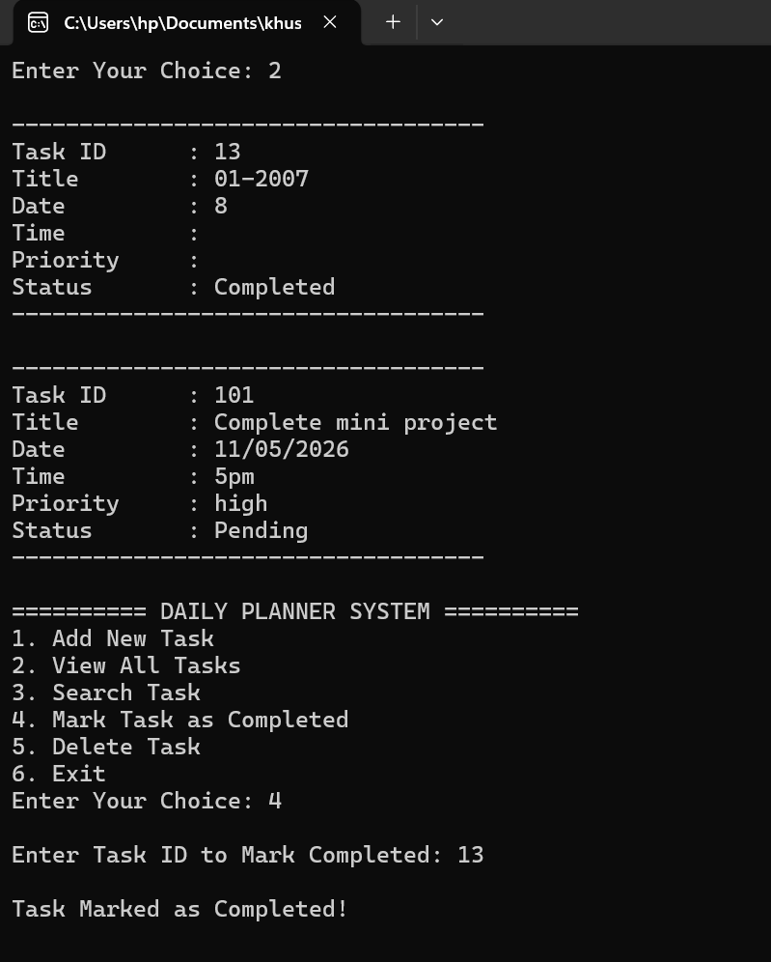
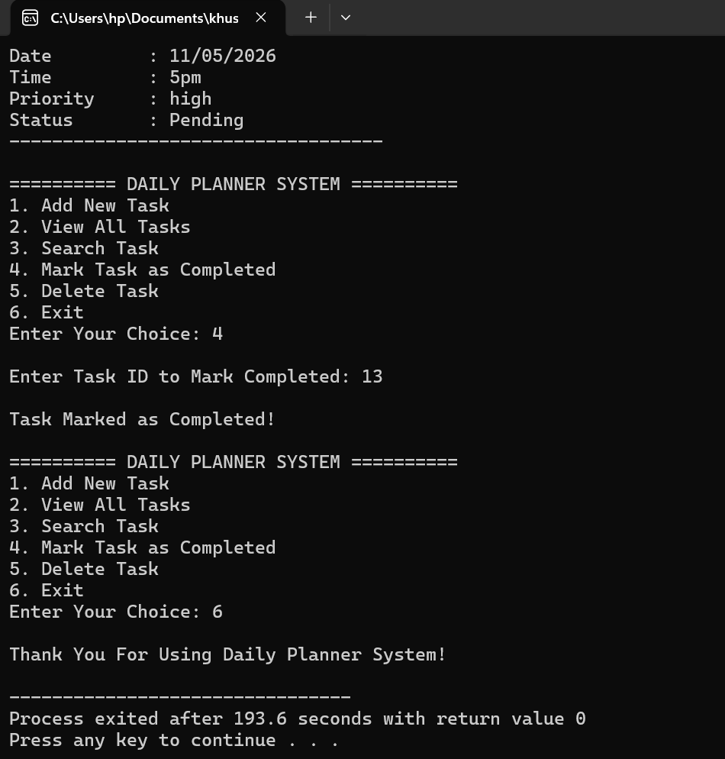

BIBLIOGRAPHY
1. Balagurusamy, E. Programming in ANSI C++, Mc Graw Hill Education
2. https://www.codewithc.com
3. https://www.mygreatlearning.com

